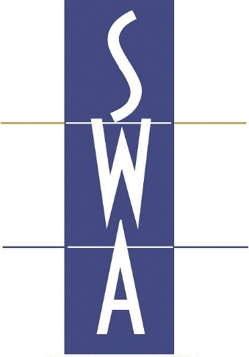

Scottish Wholesale Association

Minimum Unit Pricing and Licensing: Guidance Note for Wholesalers

Please note that this document is guidance only and you should seek your own independent legal advice.

Table of Contents
Introduction 3
Overview: what is Minimum Unit Pricing? 3
When will MUP apply? 3
Section 1: Will MUP affect my business? 4
Why may a premises licence trigger MUP? 4
Does my premises licence cover sales to trade? 4
Section 2: sales "under and in accordance with" the premises licence Error! Bookmark not defined.
Section 3: Dual Pricing 6
Why dual pricing? 6
How would dual pricing work? 6
What is a hospitality sale? 6
Section 4: Implementing and calculating MUP 7
How to calculate MUP 7
Worked examples: 7
Multipacks 8
Pre-mixed drinks 8
Online orders and deliveries 9
Section 5: Operating dual pricing system and due diligence. 9
Section 6: Getting MUP ready 9
Review pricing 9
Staff training non-hospitality sales 10
Section 7: MUP and promotions 11
Special offers 11
Discount coupons 11
How does this impact on your customers? 12

Introduction

Overview: what is Minimum Unit Pricing?
Minimum Unit Pricing (“MUP”) is a measure introduced by the Scottish Government and will be embedded in law by the Alcohol (Minimum Pricing) (Scotland) Act 2012 which is to come into force on 1 May 2018.

MUP sets a price below which alcohol cannot be sold under a premises licence. It will not necessarily increase the price of all alcoholic drinks. The minimum price is 50p per unit of alcohol. A unit is 10ml or 8g of pure alcohol.

The overarching aim of MUP is to tackle Scotland’s unhealthy relationship with alcohol. The Scottish Government's position is that increasing affordability increases consumption and that in turn increases alcohol related illness, deaths and anti-social behaviours.

The Scottish Government’s aim is to reduce the purchase of cheap, strong alcohol which they maintain is drunk by the heaviest drinkers.

When will MUP apply?
MUP will be implemented by way of a condition on all premises licences and occasional licences and requires all alcohol sold under and in accordance with these licences to be sold at, or above the minimum price per unit.

Therefore, all sales of alcohol sold under and in accordance with a premises licence must comply with MUP. Failure to do so is a breach of that premises licence and a criminal offence.

Sales of alcohol which are not regulated by a premises licence will not be caught by MUP.

Section 1: Will MUP affect my business?

How MUP affects your business depends on whether you have a premises licence in terms of the Licensing (Scotland) Act 2005 ("the Act").

However, it is important to note that MUP will impact on your customers. The price at which your customers can sell alcohol may increase.

PREMISES LICENCE |  | MUP IS A RELEVANT FACTOR
NO PREMISES LICENCE |  | BUSINESS AS USUAL (see section: MUP and promotions)

Why might a premises licence trigger MUP?
SWA are aware that some wholesalers have a premises licence and others do not.

Companies might attract a mixture of customers including non-licence trade customers, licensed trade who purchase alcohol for sale on their licensed premises and individual customers who purchase for domestic consumption.

MUP will become a mandatory condition of the premises licence. It will apply to certain sales made under and in accordance with the premises licence. Therefore, if you do not have a premise licence and provided you are satisfied that you do not need one, then MUP is only a concern for your customers who will sell the alcohol on. It is important that you satisfy yourself that appropriate measures are put in place in your business to make sure that the terms of the premises licence are complied with.

Failure to comply with MUP is a breach of the premises licence and is a criminal offence.

Does my premises licence cover sales to trade?
A premises licence, allows the sale of alcohol on a premises and is granted under and in terms of the Licensing (Scotland) Act 2005 ("the Act"), but there are exceptions to the requirement to hold a licence. These exemptions are:-

1) defined exempt premises (for example an aircraft, or train while engaged on journey) and;

2) premises selling to trade.

The Act defines sales to trade as "selling the alcohol or goods to a person for the purposes of the person's trade". This is generally taken to refer to licensed trade and retailers so for the purposes of this guidance note, we will refer to those sales as "hospitality sales".

Persons making hospitality sales, must make those sales from licensed premises or, if not, from premises which are used exclusively for hospitality sales (i.e. no public access) – if they do not, they commit an offence.

It is important to note that a business which exclusively makes hospitality sales does not need to hold a premises licence, they are exempted from the requirement to hold a licence in terms of the Act. However, if they were to make a sale otherwise than a hospitality sale then they would be committing a criminal offence (see Section on Due Diligence).

A business which makes hospitality sales, but sells alcohol to other non-hospitality traders as well and perhaps the general public, will need a premises licence. A number of wholesalers hold premises licences for these reasons. Others take the view that as they only sell to the hospitality trade, they do not need to hold a licence. If you are in doubt, please seek legal advice on this point.

The mandatory conditions of the premises licence will apply to the non-hospitality sales, i.e. the sale of alcohol to members of the public/other trade sales. As noted above MUP is a condition of a premises licence and therefore, all such sales of alcohol must be above MUP.

Most onward hospitality sales will be made under and in accordance with a premises licence and thus MUP will apply to these onward sales - for example the hotelier who purchases a pack of beer at under MUP from her/his wholesaler will be required to retail that same pack of beer at MUP to the consuming customer.

Section 2: sales "under and in accordance with" the premises licence

The premises licence is made up of a summary, an operating plan (which gives details of what happens on the premises, hours, activities, additional information), a layout plan (showing the designated licensed alcohol area, dimensions, firefighting equipment, access points) and conditions – both mandatory and special (bespoke to the premises).

Mandatory conditions that apply to premises licences include (amongst other points):

- Selling alcohol only in accordance with the operating plan
- Ensuring staff are appropriately trained
- Conditions on the pricing of alcohol
- Detailing what would be an irresponsible drinks promotion
- Limits on off sales display and promotions

Premises licences allow the sale of alcohol on an "on sales", (sale for consumption on the premises), and "off sales", (sale for consumption off the premises) basis and/or both.

Maximum off sales hours are set by statute and are 10am to 10pm.

Section 3: Dual Pricing

Why dual pricing?
A business which holds a premises licence for sales to the public or non-hospitality sales must sell alcohol "under and in accordance with" the terms of that licence. Hospitality sales – as they are exempt from the 2005 Act – do not need to comply with the terms of the premises licence, i.e. hospitality sales do not need to comply with MUP.

As such you can offer alcohol at two prices:

- MUP price for non-hospitality sales
- Non MUP price for hospitality sales

How would dual pricing work?
If you sell alcohol to both the public and/or other trade and also the hospitality trade, then a dual pricing system can be in place on the licensed premises and advertised to customers. There are two components to this:

- Clear pricing of alcoholic products with the "Hospitality Sale" and "Trade/Public" price marked
- Determining when a hospitality sale is taking place

What is a hospitality sale?
As previously noted the Act defines sales to trade as "selling the alcohol or goods to a person for the purposes of the person's trade". Therefore, it is not sufficient that the customer has a business or a trade membership.

A hospitality sale must be a sale made for the purposes of the customer's trade.

For example:

- Operator of an off sales purchasing alcohol as stock for the off sales – HOSPITALITY SALE
- Restaurant owner buying wine to serve at his restaurant - HOSPITALITY SALE
- Limousine operator purchasing alcohol for use in his private hire business – HOSPITALITY SALE
- Employee of catering company buying alcohol to serve at functions - HOSPITALITY SALE
- Operator of an off sales buying alcohol to consume at home – NONHOSPITALITY SALE
- Office worker buying alcohol to gift as personal gifts - NONHOSPITALITY SALE

The Act does not expressly define "trade" although the words "for the purposes of" indicate that hospitality sales were (and are) exempt.

Given that Parliament's intent is not entirely clear, as to whether trade is solely the licensed/hospitality trade or expands to include anyone's trade, for example:

- A housebuilder buying wine from a wholesaler to give to house buyers on a complimentary basis
- A law firm purchasing alcohol for serving at a client event.
- A hairdresser purchasing alcohol to serve in their business.
- A chef in a nursing home who is purchasing alcohol for use in cooking

it will be a matter for you to take your own independent legal advice to determine whether you are satisfied that the above examples constitute a defined hospitality sale.

Section 4: Implementing and calculating MUP

As set out in Section 3: Dual Pricing, MUP is a condition of the premises licence and therefore, needs to be applied to all non-hospitality sales. It is the premises licence holder and in turn the Designated Premises Manager’s responsibility to make sure that all alcohol sales made under and in accordance with the premises licence (sales to the public/non-hospitality sales) comply with MUP. Licensing Standards Officers will be tasked with enforcing MUP in terms of the Premises Licence.

How to calculate MUP

Price per unit | x | ABV | / | 100 | x | Volume | x | 100 | = | MUP

Worked examples:

Vodka (1 litre bottle)
Price per unit |  | ABV |  |  |  | Volume |  |  |  | MUP
0.50 | x | 37.5 | / | 100 | x | 1 | x | 100 | = | £18.75

Vodka (70cl bottle)
Price per unit |  | ABV |  |  |  | Volume |  |  |  | MUP
0.50 | x | 37.5 | / | 100 | x | 0.70 | x | 100 | = | £13.13

6 pack of beer (300ml bottles)
Price per unit |  | ABV |  |  |  | Volume |  |  |  | MUP
0.50 | x | 4.8 | / | 100 | x | 1.8 | x | 100 | = | £4.32

Wine (75cl bottle at 13.5% ABV)
Price per unit |  | ABV |  |  |  | Volume |  |  |  | MUP
0.50 | x | 13.5 | / | 100 | x | 0.75 | x | 100 | = | £5.06

Wine (75cl bottle at 14.5% ABV)
Price per unit |  | ABV |  |  |  | Volume |  |  |  | MUP
0.50 | x | 14.5 | / | 100 | x | 0.75 | x | 100 | = | £5.44

4 pack of beer (500ml cans)
Price per unit |  | ABV |  |  |  | Volume |  |  |  | MUP
0.50 | x | 4 | / | 100 | x | 2 | x | 100 | = | £4.00

Champagne / Sparkling wine
Price per unit |  | ABV |  |  |  | Volume |  |  |  | MUP
0.50 | x | 12 | / | 100 | X | 0.75 | x | 100 | = | £4.50

Multipacks
In order to calculate the MUP of a multipack of alcohol, for example a box of eight cans of lager, the single can price should be calculated first and then multiplied by the number of cans in the multipack. For example:

Price per unit |  | ABV |  |  |  | Volume |  |  |  | MUP
0.50 | x | 6 | / | 100 | x | 0.33 | x | 100 | = | £0.99

8 cans in the multipack = 8 x0.99 = MUP £7.92

Pre-mixed drinks
If a product is pre-mixed, such as vodka and cola, then the abv that is printed on the can or bottle should be utilised. For example, a pre-mixed can of whisky and cola would have a MUP as follows:

Price per unit |  | ABV |  |  |  | Volume |  |  |  | MUP
0.50 | x | 5 | / | 100 | x | 0.33 | x | 100 | = | £0.83

Online orders and deliveries
Non-hospitality sales made through online orders and deliveries made in accordance with the Premises Licence will of course be caught by MUP. However, if the alcohol is dispatched directly to a customer from a premises in England and Wales, as MUP is a condition only of Scottish premises licences then any alcohol dispatched from England and Wales would not be caught.

Section 5: Operating dual pricing system and due diligence.

The key to accepting hospitality sales will be to ensure that the alcohol is being sold to the person for the purpose of the person's trade. If a membership scheme is in operation, wholesalers may consider the creation of a separate group membership-
"hospitality sales" and request all or some of the following as ways to verify a customer's membership application:

- Production of a principal premises licence or certified copy of same;
- Receipt showing payment of annual fee for premises licence
- Statement from a professional advisor in respect of the customer/member's business
- Original copy of statement of business rates

Terms of membership of this group could include an undertaking that the customer acknowledges and accepts that all purchases of alcohol from the wholesaler using this membership are made solely for the purposes of that person's trade. Creation of a specific "membership group" with a membership card or other identifying product will assist in ascertaining price points at the point of sale.

Such records obtained should be stored and be made available to licensing standards or police officers on request.

For further guidance, please seek individual legal advice.

Section 6: Getting MUP ready

Review pricing
You must carefully review the pricing of all your alcohol stock and create a dual pricing structure to reflect hospitality and public/non-hospitality sales.

The MUP of each alcoholic product must be calculated and the prices clearly noted for non-hospitality sales, making sure that it is above the MUP.

Once you’ve re-priced all your alcoholic products then it may be useful to print a list of products and their price so that this can be produced to any Licensing Standards Officer who visits the depot/store.

Staff training non-hospitality sales
It is a condition of all premises licences that staff involved in the sale of alcohol have two hours mandatory training.

This training must be supplemented with bespoke training in relation to the operation of MUP delivered by a personal licence holder or an accredited trainer.

It is also important from a customer relations standpoint that your staff are able to answer any questions that your customers may have, particularly in relation to dual pricing and hospitality sales.

Having a written record of this training is good practice and will assist with any visits by Licensing Standards Officers/Police Scotland.

The training should cover the following points:

- What is MUP?
- Why does it not apply to some sales of alcohol?
- Sales made under the premises licence: failure to comply is a breach of the premises licence and a criminal offence.
- How to calculate the MUP.
- Ensuring pricing is kept up to date.
- Differences between hospitality and non-hospitality sales.

Section 7: MUP and promotions

Special offers
It is vital that no special offer results in the price of the alcohol being reduced below the MUP.

When creating a new special offer the following steps should be followed:

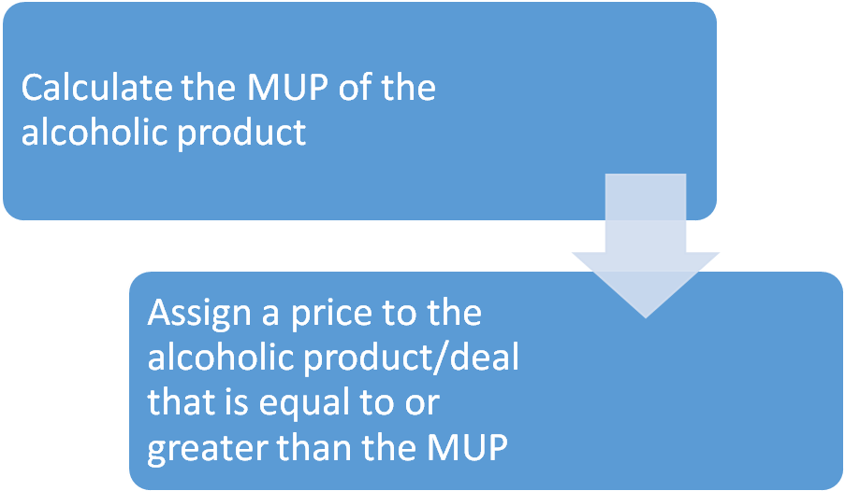

You are running a promotion whereby a 4 pack of beer (4% ABV / 440ml) is reduced from £3.75 to £3. This would be illegal as the MUP is £3.52.

You are offering a bottle of champagne (12% ABV / 75cl) reduced from £25 to £20. This is a legal promotion as the MUP is £4.50.

A bottle of wine is offered in a package along with a selection of cheeses at £9.50. This package cannot be sold for less than the MUP of the bottle of wine – e.g. if the MUP of the wine is £4.50 then the package cannot be sold at a price less than £4.50. Therefore, this is a legal promotion.

A customer upon buying their shop receives £10 off if they spend £30 or more. In their shop are four bottles of whisky (40% ABV / 1ltr) which have a combined MUP of £80 (£20 x 4). The total shop comes to £85. The proposed reduction would mean the shop costs £75. This is under the MUP of the alcoholic products involved and is therefore an illegal promotion.

Discount coupons
MUP does not make discount coupons illegal, however, they cannot be used to reduce the price of an alcoholic product below the MUP.

How does this impact on your customers?
We appreciate that it is important that you support your customers during the introduction of MUP. This can be done by displaying posters and distributing leaflets which the SWA have produced. This will assist in raising awareness of its introduction on 1 May 2018.

Any changes to membership as outlined in Section 5 represent an opportunity for your business to engage with customers on the implementation.

The key points for your customers are:

- All alcohol sold by them must comply with MUP; and
- No special offers or promotions can reduce the price of an alcoholic product below MUP.

SWA is keen to hear from wholesalers about any positives or negatives encountered around implementation of this new piece of legislation. Please contact us directly to give your feedback.

Section 117 of the Licensing (Scotland) Act 2005
Section 1 (2) of the Licensing (Scotland) Act 2005 https://www.legislation.gov.uk/asp/2005/16/section/1

