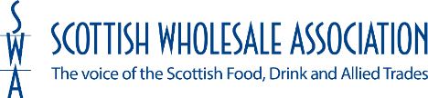

MAINTAINING ESSENTIAL SERVICES: KEY TRAVEL PROVISIONS

To whom it may concern

Scottish Government guidance announced on 23rd March 2020 set out a series of measures to reduce the spread of the COVID-19 virus, including the closure of businesses deemed non-essential and the restriction on the public’s movements for all but “essential” travel.

Further guidance announced by the First Minister on 24th March 2020 defined ‘essential businesses’ to include those involved in the supply of food. Incorporating the production, distribution, sale and delivery of food, as well as those essential to the provision of other key goods such as medicines.

The Scottish Wholesale Association is the representative trade body for a large number of companies which are within this definition. We are also a member of the Scottish Government’s Food Resilience Group responsible for advising on the continuity of food supplies and related contingency measures.

This letter certifies that the company named below

--------------------------------------------------

falls within this category and that the person or persons listed below fill roles which are necessary for the continuation of the essential services which their employers provide and are therefore eligible for ‘essential travel’ status.

--------------------------------------------------

--------------------------------------------------

Please direct any enquiries to the company concerned in the first instance, who will refer them to us where necessary.

Colin Smith
Chief Executive
Scottish Wholesale Association

